**Git new:---**

Step1:-- first install two instance in two different region:----Ohio/Singapore

Step2:--update yum server:--

#yum update -y

OHIO:----

login as: ec2-user

Authenticating with public key "imported-openssh-key"

[ec2-user@ip-172-31-19-164 ~]$ sudosu

[root@ip-172-31-19-164 ec2-user]# yum update -y

Updating Subscription Management repositories.

Unable to read consumer identity

This system is not registered to Red Hat Subscription Management. You can use subscription-manager to register.

Red Hat Update Infrastructure 3 Client Configur 17 kB/s | 4.2 kB 00:00

Red Hat Enterprise Linux 8 for x86_64 - AppStre 24 MB/s | 39 MB 00:01

Red Hat Enterprise Linux 8 for x86_64 - BaseOS 39 MB/s | 44 MB 00:01

Dependencies resolved.

================================================================================

Package Arch Version Repository Size

================================================================================

Installing:

kernel x86_64 4.18.0-348.12.2.el8_5

rhel-8-baseos-rhui-rpms 7.0 M

kernel-core x86_64 4.18.0-348.12.2.el8_5

rhel-8-baseos-rhui-rpms 38 M

kernel-modules x86_64 4.18.0-348.12.2.el8_5

rhel-8-baseos-rhui-rpms 30 M

Upgrading:

NetworkManager x86_64 1:1.32.10-4.el8 rhel-8-baseos-rhui-rpms 2.6 M

NetworkManager-cloud-setup

x86_64 1:1.32.10-4.el8 rhel-8-appstream-rhui-rpms 185 k

NetworkManager-libnm x86_64 1:1.32.10-4.el8 rhel-8-baseos-rhui-rpms 1.8 M

NetworkManager-team x86_64 1:1.32.10-4.el8 rhel-8-baseos-rhui-rpms 149 k

NetworkManager-tui x86_64 1:1.32.10-4.el8 rhel-8-baseos-rhui-rpms 336 k

authselect x86_64 1.2.2-3.el8 rhel-8-baseos-rhui-rpms 133 k

authselect-compat x86_64 1.2.2-3.el8 rhel-8-appstream-rhui-rpms 38 k

authselect-libs x86_64 1.2.2-3.el8 rhel-8-baseos-rhui-rpms 222 k

bash x86_64 4.4.20-2.el8 rhel-8-baseos-rhui-rpms 1.5 M

bind-export-libs x86_64 32:9.11.26-6.el8 rhel-8-baseos-rhui-rpms 1.1 M

ca-certificatesnoarch 2021.2.50-80.0.el8_4

rhel-8-baseos-rhui-rpms 390 k

chkconfig x86_64 1.19.1-1.el8 rhel-8-baseos-rhui-rpms 198 k

chrony x86_64 4.1-1.el8 rhel-8-baseos-rhui-rpms 327 k

cloud-initnoarch 21.1-7.el8_5.3 rhel-8-appstream-rhui-rpms 1.0 M

cloud-utils-growpartnoarch 0.31-3.el8 rhel-8-appstream-rhui-rpms 32

**Then install the git package:------**

[root@ip-172-31-19-164 ec2-user]# yum install git -y

Updating Subscription Management repositories.

Unable to read consumer identity

This system is not registered with an entitlement server. You can use subscription-manager to register.

Last metadata expiration check: 0:05:14 ago on Thu 24 Feb 2022 09:18:27 AM UTC.

Dependencies resolved.

================================================================================

Package Arch Version Repository Size

================================================================================

Installing:

git x86_64 2.27.0-1.el8 rhel-8-appstream-rhui-rpms 164 k

Installing dependencies:

emacs-filesystemnoarch 1:26.1-7.el8 rhel-8-baseos-rhui-rpms 70 k

git-core x86_64 2.27.0-1.el8 rhel-8-appstream-rhui-rpms 5.7 M

git-core-docnoarch 2.27.0-1.el8 rhel-8-appstream-rhui-rpms 2.5 M

perl-Carpnoarch 1.42-396.el8 rhel-8-baseos-rhui-rpms 30 k

perl-Data-Dumper x86_64 2.167-399.el8 rhel-8-baseos-rhui-rpms 58 k

perl-Digestnoarch 1.17-395.el8 rhel-8-appstream-rhui-rpms 27 k

perl-Digest-MD5 x86_64 2.55-396.el8 rhel-8-appstream-rhui-rpms 37 k

perl-Encode x86_64 4:2.97-3.el8 rhel-8-baseos-rhui-rpms 1.5 M

perl-Errno x86_64 1.28-420.el8 rhel-8-baseos-rhui-rpms 76 k

perl-Errornoarch 1:0.17025-2.el8 rhel-8-appstream-rhui-rpms 46 k

perl-Exporternoarch 5.72-396.el8 rhel-8-baseos-rhui-rpms 34 k

perl-File-Pathnoarch 2.15-2.el8 rhel-8-baseos-rhui-rpms 38 k

perl-File-Tempnoarch 0.230.600-1.el8 rhel-8-baseos-rhui-rpms 63 k

perl-Getopt-Longnoarch 1:2.50-4.el8 rhel-8-baseos-rhui-rpms 63 k

perl-Gitnoarch 2.27.0-1.el8 rhel-8-appstream-rhui-rpms 78 k

perl-HTTP-Tinynoarch 0.074-1.el8 rhel-8-baseos-rhui-rpms 58 k

perl-IO x86_64 1.38-420.el8 rhel-8-baseos-rhui-rpms 142 k

perl-MIME-Base64 x86_64 3.15-396.el8 rhel-8-baseos-rhui-rpms

**check the git package:------**

[root@ip-172-31-19-164 ec2-user]# which git

/bin/git

[root@ip-172-31-49-23 ec2-user]# rpm -qa git*

[root@ip-172-31-19-164 ec2-user]# git --version

git version 2.27.0

**do global configuration for git:---**

[root@ip-172-31-19-164 ec2-user]# r.namegit config --global use "abhash"

[root@ip-172-31-19-164 ec2-user]# git config --global user.email "abhashkumar1993@gmail.com"

[root@ip-172-31-19-164 ec2-user]# git config --list

user.name=abhash

user.email=abhashkumar1993@gmail.com

[root@ip-172-31-19-164 ec2-user]#

Create account on github:

[GitHub](https://github.com/)

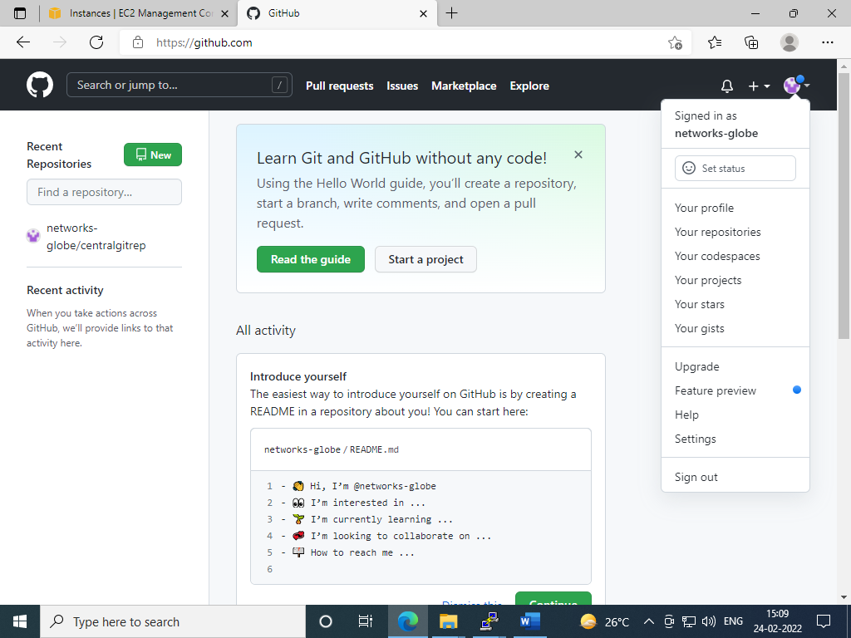

[root@ip-172-31-19-164 ec2-user]# ls

ls

Make a directory for git local repo:-----

[root@ip-172-31-19-164 ec2-user]# mkdirohiogit

[root@ip-172-31-19-164 ec2-user]# ls

ohiogit

[root@ip-172-31-19-164 ec2-user]# cdohiogit

**Initialize this directory:----**

[root@ip-172-31-19-164 ohiogit]# git init

Initialized empty Git repository in /home/ec2-user/ohiogit/.git/

[root@ip-172-31-19-164 ohiogit]#

[root@ip-172-31-19-164 ohiogit]# cat > fileohio1

my name is khan

[root@ip-172-31-19-164 ohiogit]# ls

fileohio1

[root@ip-172-31-19-164 ohiogit]#

Check the git repository status:----

[root@ip-172-31-19-164 ohiogit]# git status

On branch master

No commits yet

Untracked files:

(use "git add <file>..." to include in what will be committed)

fileohio1-- pending for commit:-------

nothing added to commit but untracked files present (use "git add" to track)

[root@ip-172-31-19-164 ohiogit]#

**Now add the code file:---**

[root@ip-172-31-19-164 ohiogit]# git add .

[root@ip-172-31-19-164 ohiogit]# git status

On branch master

No commits yet

Changes to be committed:

(use "git rm --cached <file>..." to unstage)

new file: fileohio1

[root@ip-172-31-19-164 ohiogit]#

[root@ip-172-31-19-164 ohiogit]#

**Now commit the code file:-----**

[root@ip-172-31-19-164 ohiogit]# git commit -m "my first commit from ohio"

[master (root-commit) 2a759bb] my first commit from ohio

1 file changed, 1 insertion(+)

create mode 100644 fileohio1

[root@ip-172-31-19-164 ohiogit]#

[root@ip-172-31-19-164 ohiogit]# git status

git status

On branch master

nothing to commit, working tree cleannow it is showing clean

[root@ip-172-31-19-164 ohiogit]#

**To show commit log:----**

[root@ip-172-31-19-164 ohiogit]# git log

commit 2a759bba90c89f2044afc4e5ee7409e52391ebc0 (HEAD -> master)

Author: abhash<abhashkumar1993@gmail.com>

Date: Thu Feb 24 12:20:44 2022 +0000

my first commit from ohio

**to see details of git file:--**

[root@ip-172-31-19-164 ohiogit]# git show 2a759bba90c89f2044afc4e5ee7409e52391ebc0

commit 2a759bba90c89f2044afc4e5ee7409e52391ebc0 (HEAD -> master)

Author: abhash<abhashkumar1993@gmail.com>

Date: Thu Feb 24 12:20:44 2022 +0000

my first commit from ohio

diff --git a/fileohio1 b/fileohio1

new file mode 100644

index 0000000..d84b266

--- /dev/null

+++ b/fileohio1

@@ -0,0 +1 @@

+my name is khan

[root@ip-172-31-19-164 ohiogit]#



Now create the central repo in github:-----

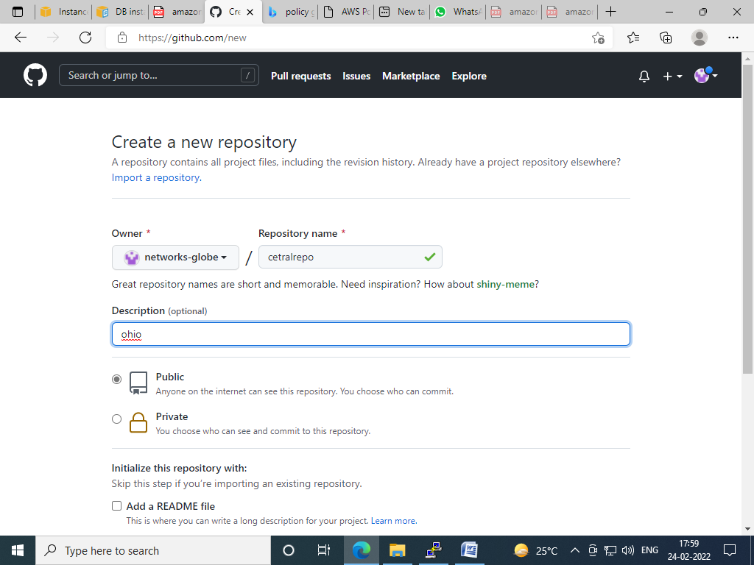

Public is free and private is chargeable:

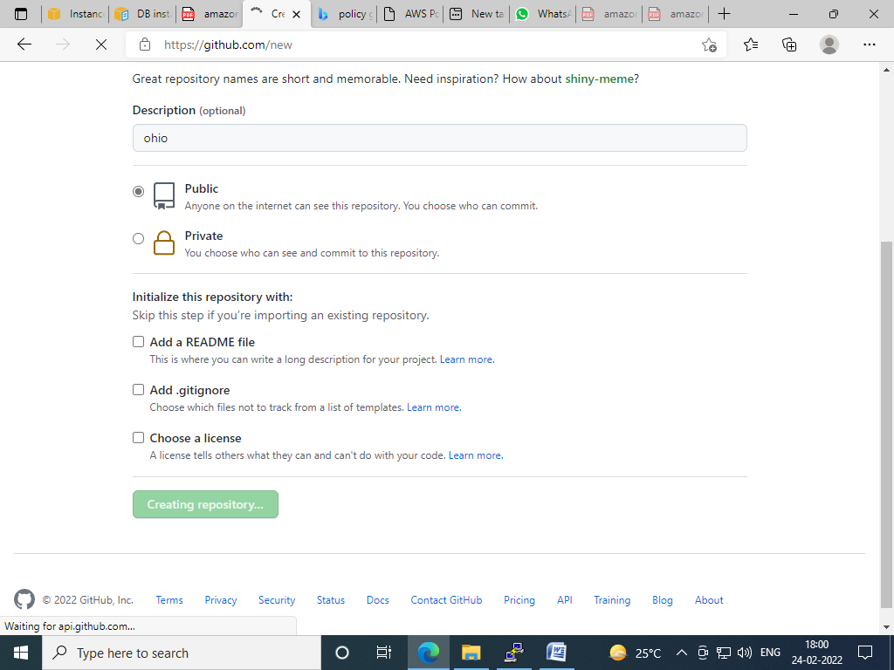

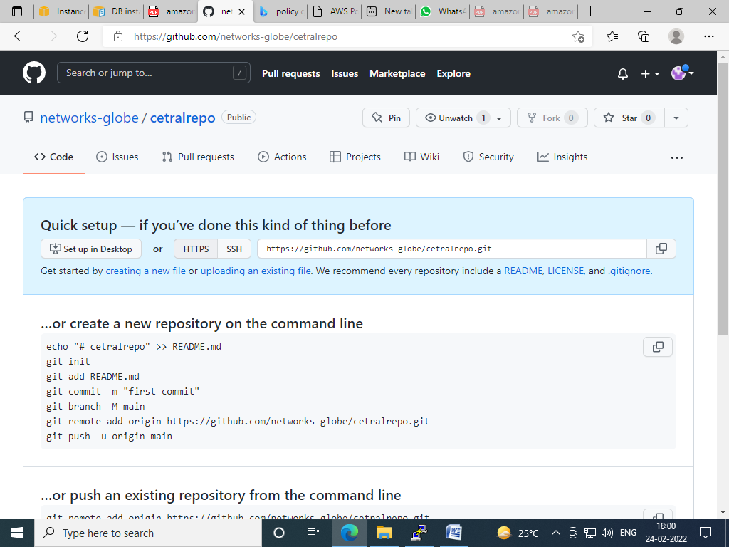

**Copy the central repo url from github:-------**

[root@ip-172-31-19-164 ohiogit]# git remote add origin https://github.com/networks-globe/cetralrepo.git

[root@ip-172-31-19-164 ohiogit]#

**Now push gitfile to github:----**

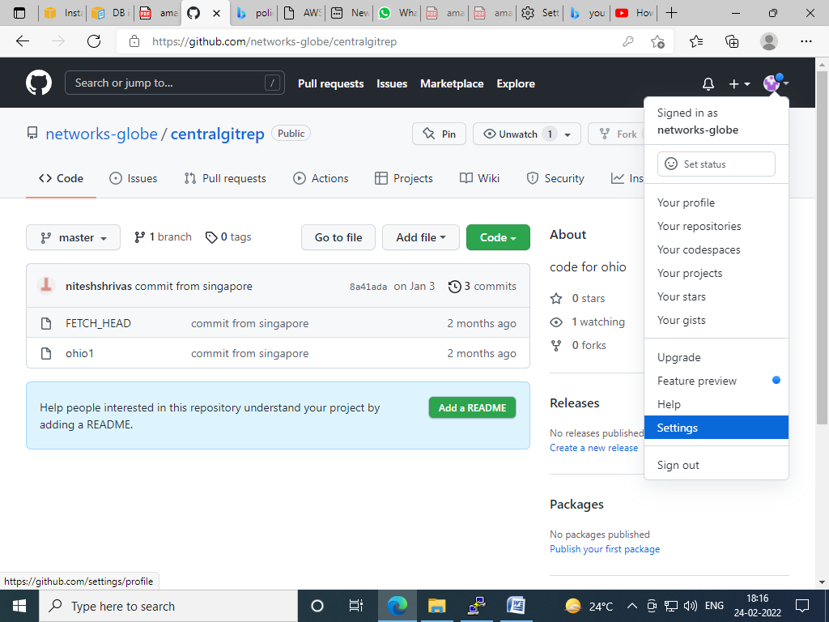

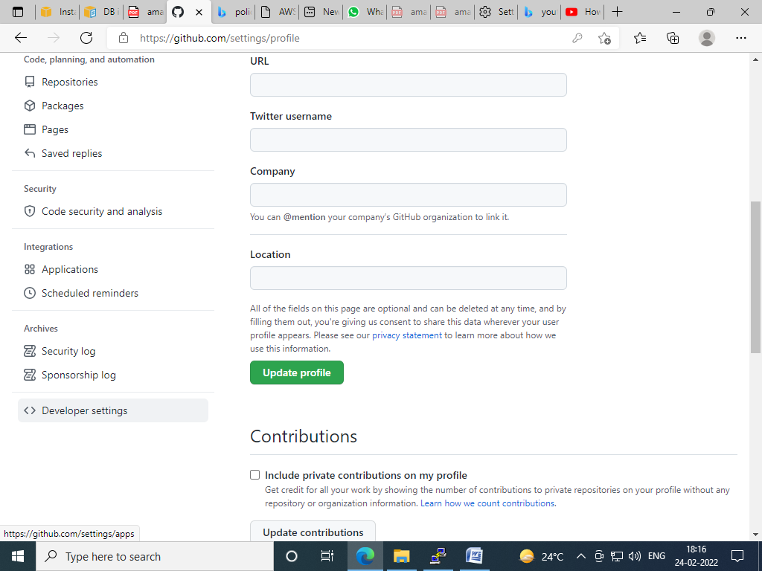

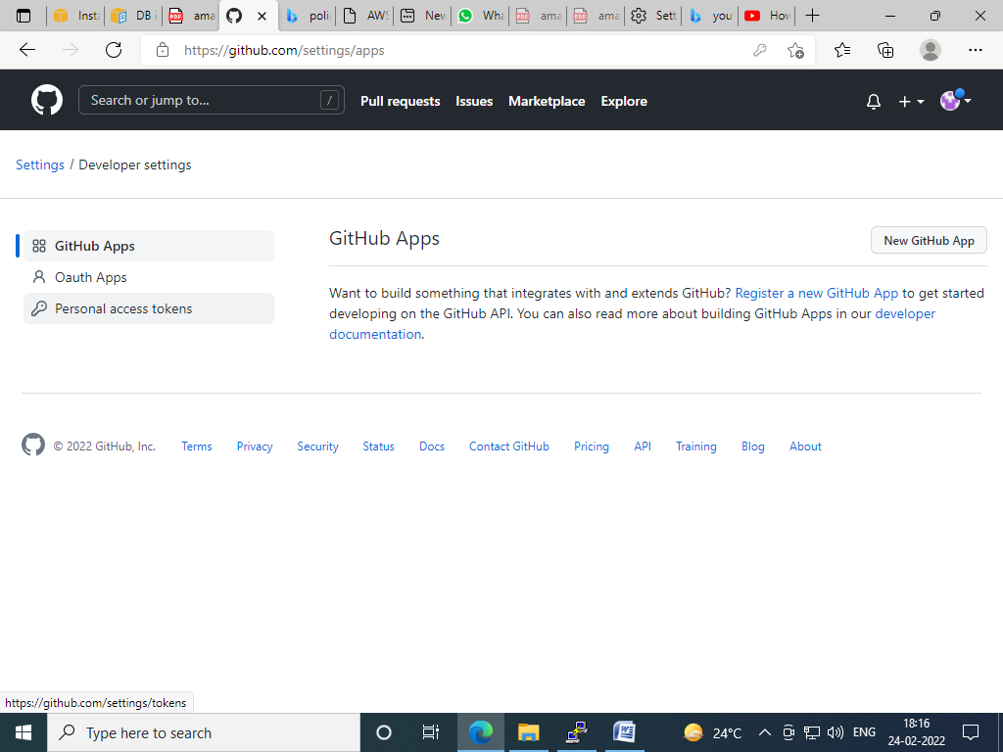

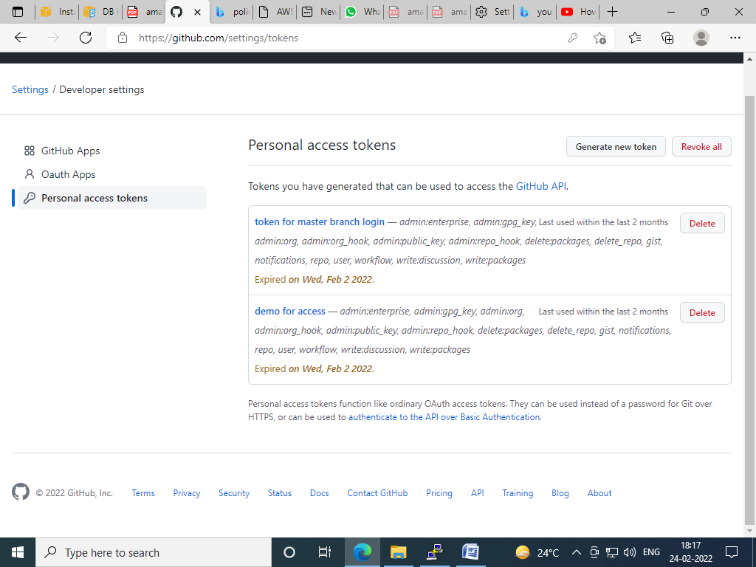

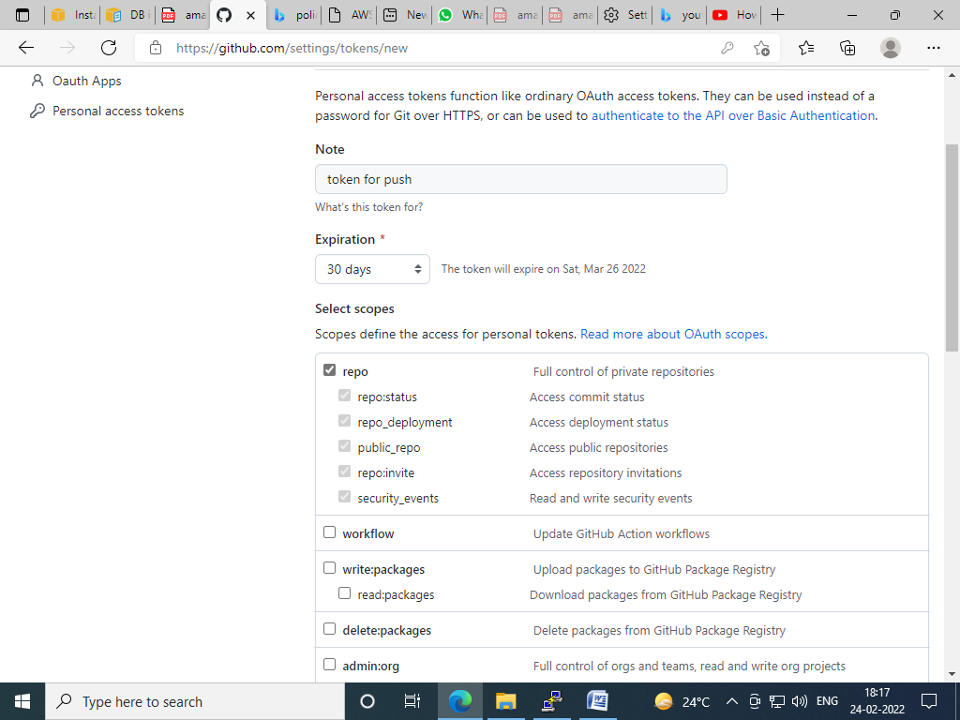

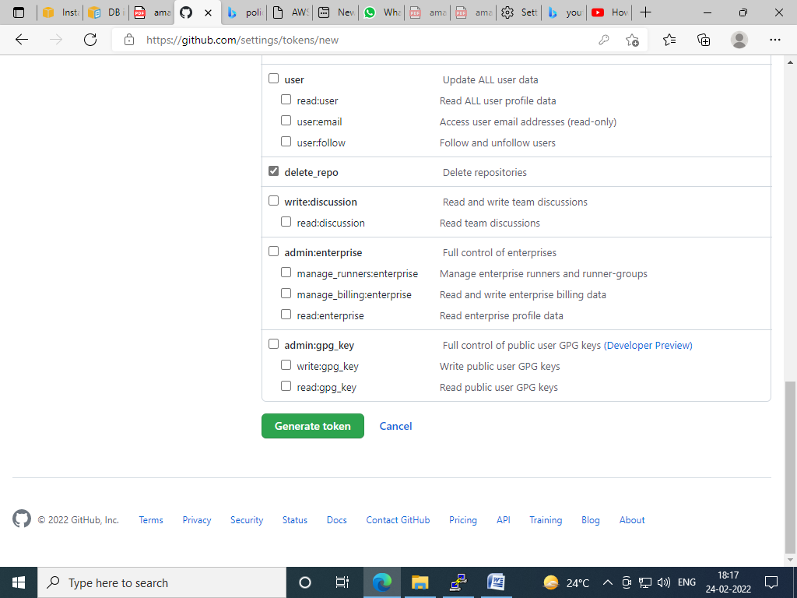

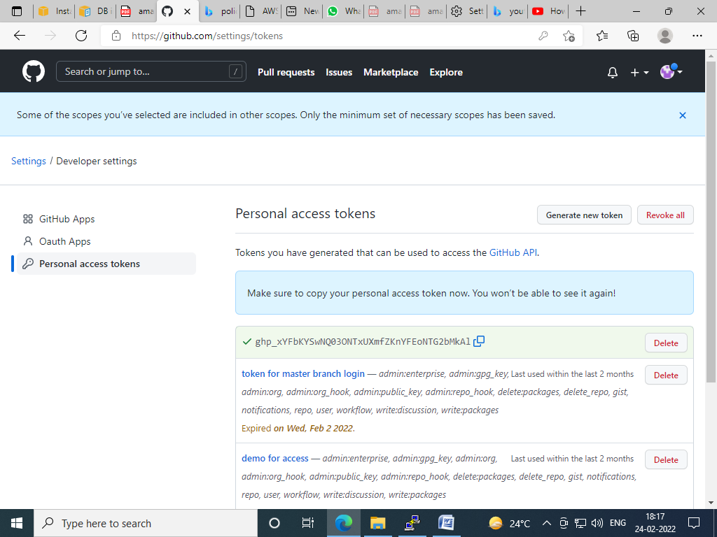

[root@ip-172-31-19-164 ohiogit]# git push -u origin master

Username for 'https://github.com': networks-globe

Password for 'https://networks-globe@github.com':enter pre-generated token

Enumerating objects: 3, done.

Counting objects: 100% (3/3), done.

Writing objects: 100% (3/3), 236 bytes | 236.00 KiB/s, done.

Total 3 (delta 0), reused 0 (delta 0), pack-reused 0

To https://github.com/networks-globe/cetralrepo.git

* [new branch] master -> master

Branch 'master' set up to track remote branch 'master' from 'origin'.

[root@ip-172-31-19-164 ohiogit]#

**Now verify file in github:-----**

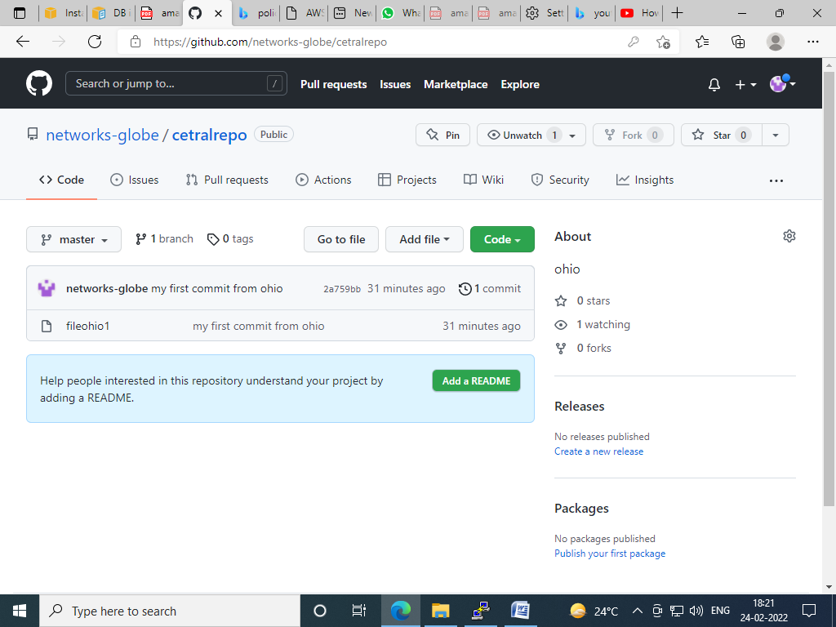

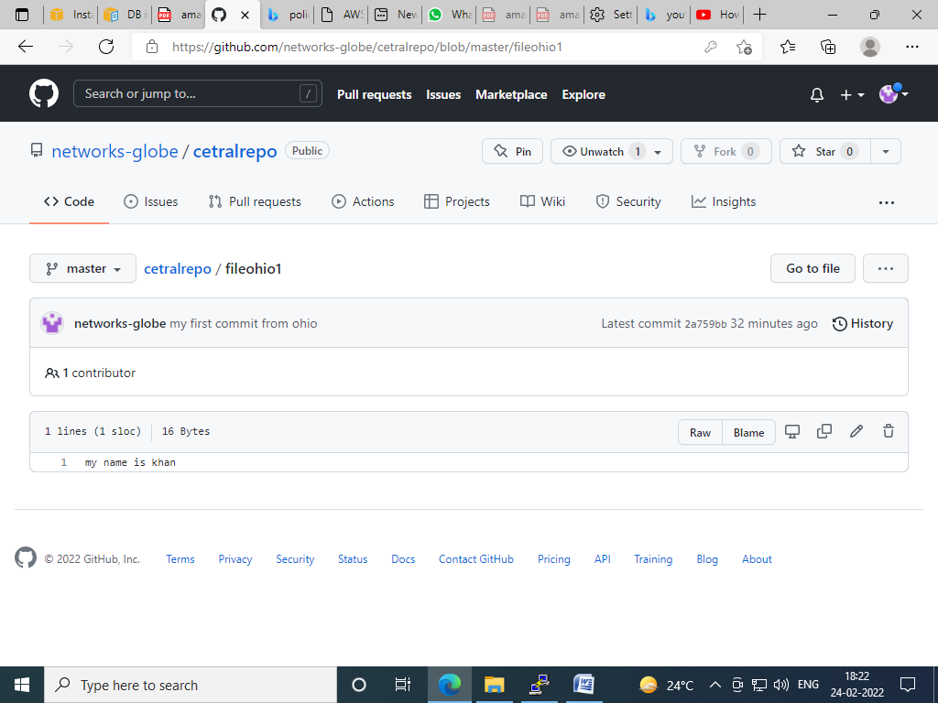

**Now do some modification in github:---**

[root@ip-172-31-19-164 ohiogit]# ls

fileohio1

[root@ip-172-31-19-164 ohiogit]# cat>> fileohio1

i am not terrorist

[root@ip-172-31-19-164 ohiogit]# git status

On branch master

Your branch is up to date with 'origin/master'.

Changes not staged for commit:

(use "git add <file>..." to update what will be committed)

(use "git restore <file>..." to discard changes in working directory)

modified: fileohio1now it is showing some modification

no changes added to commit (use "git add" and/or "git commit -a")

[root@ip-172-31-19-164 ohiogit]#

[root@ip-172-31-19-164 ohiogit]# git add .

[root@ip-172-31-19-164 ohiogit]# git status

On branch master

Your branch is up to date with 'origin/master'.

Changes to be committed:

(use "git restore --staged <file>..." to unstage)

modified: fileohio1

[root@ip-172-31-19-164 ohiogit]# git commit -m "my second code from ohio"

[master b69e0a9] my second code from ohio

1 file changed, 1 insertion(+)

[root@ip-172-31-19-164 ohiogit]# git status

On branch master

Your branch is ahead of 'origin/master' by 1 commit.

(use "git push" to publish your local commits)

nothing to commit, working tree clean

[root@ip-172-31-19-164 ohiogit]#

[root@ip-172-31-19-164 ohiogit]#

[root@ip-172-31-19-164 ohiogit]# git log

commit b69e0a9c4a88fc46633dec5ad3aec0fc419a4f26 (HEAD -> master)

Author: abhash<abhashkumar1993@gmail.com>

Date: Thu Feb 24 12:58:30 2022 +0000

my second code from ohio

commit 2a759bba90c89f2044afc4e5ee7409e52391ebc0 (origin/master)

Author: abhash<abhashkumar1993@gmail.com>

Date: Thu Feb 24 12:20:44 2022 +0000

my first commit from ohio

[root@ip-172-31-19-164 ohiogit]#

[root@ip-172-31-19-164 ohiogit]# git show b69e0a9c4a88fc46633dec5ad3aec0fc419a4f26

commit b69e0a9c4a88fc46633dec5ad3aec0fc419a4f26 (HEAD -> master)

Author: abhash<abhashkumar1993@gmail.com>

Date: Thu Feb 24 12:58:30 2022 +0000

my second code from ohio

diff --git a/fileohio1 b/fileohio1

index d84b266..f87ad76 100644

--- a/fileohio1

+++ b/fileohio1

@@ -1 +1,2 @@

my name is khan

+i am not terrorist

[root@ip-172-31-19-164 ohiogit]#

[root@ip-172-31-19-164 ohiogit]# git push origin master

Username for 'https://github.com': networks-globe

Password for 'https://networks-globe@github.com':

Enumerating objects: 5, done.

Counting objects: 100% (5/5), done.

Writing objects: 100% (3/3), 283 bytes | 283.00 KiB/s, done.

Total 3 (delta 0), reused 0 (delta 0), pack-reused 0

To https://github.com/networks-globe/cetralrepo.git

2a759bb..b69e0a9 master -> master

**Now do same process in Singapore site:---**

**SINGAPORE:-----**

login as: ec2-user

Authenticating with public key "imported-openssh-key"

[ec2-user@ip-172-31-22-40 ~]$ sudosu

[root@ip-172-31-22-40 ec2-user]# yum update -y

Updating Subscription Management repositories.

Unable to read consumer identity

This system is not registered with an entitlement server. You can use subscription-manager to register.

Red Hat Enterprise Linux 8 for x86_64 - AppStre 34 MB/s | 39 MB 00:01

Red Hat Enterprise Linux 8 for x86_64 - BaseOS 30 MB/s | 44 MB 00:01

Red Hat Update Infrastructure 3 Client Configur 22 kB/s | 4.3 kB 00:00

Dependencies resolved.

================================================================================

Package Arch Version Repository Size

================================================================================

Installing:

kernel x86_64 4.18.0-348.12.2.el8_5 rhel-8-baseos-rhui-rpms 7.0 M

kernel-core x86_64 4.18.0-348.12.2.el8_5 rhel-8-baseos-rhui-rpms 38 M

kernel-modules x86_64 4.18.0-348.12.2.el8_5 rhel-8-baseos-rhui-rpms 30 M

Upgrading:

cloud-initnoarch 21.1-7.el8_5.3 rhel-8-appstream-rhui-rpms 1.0 M

cryptsetup-libs x86_64 2.3.3-4.el8_5.1 rhel-8-baseos-rhui-rpms 474 k

cyrus-sasl-lib x86_64 2.1.27-6.el8_5 rhel-8-baseos-rhui-rpms 123 k

dnf-plugins-corenoarch 4.0.21-4.el8_5 rhel-8-baseos-rhui-rpms 70 k

kernel-tools x86_64 4.18.0-348.12.2.el8_5 rhel-8-baseos-rhui-rpms 7.2 M

kernel-tools-libs

x86_64 4.18.0-348.12.2.el8_5 rhel-8-baseos-rhui-rpms 7.0 M

kexec-tools x86_64 2.0.20-57.el8_5.1 rhel-8-baseos-rhui-rpms 514 k

libgcc x86_64 8.5.0-4.el8_5 rhel-8-baseos-rhui-rpms 80 k

libgomp x86_64 8.5.0-4.el8_5 rhel-8-baseos-rhui-rpms 206 k

libsss_autofs x86_64 2.5.2-2.el8_5.4 rhel-8-baseos-rhui-rpms 119 k

libsss_certmap x86_64 2.5.2-2.el8_5.4 rhel-8-baseos-rhui-rpms 156 k

libsss_idmap x86_64 2.5.2-2.el8_5.4 rhel-8-baseos-rhui-rpms 121 k

libsss_nss_idmap x86_64 2.5.2-2.el8_5.4 rhel-8-baseos-rhui-rpms 128 k

libsss_sudo x86_64 2.5.2-2.el8_5.4 rhel-8-baseos-rhui-rpms 117 k

libstdc++ x86_64 8.5.0-4.el8_5 rhel-8-baseos-rhui-rpms 453 k

openssl x86_64 1:1.1.1k-5.el8_5 rhel-8-baseos-rhui-rpms 709 k

openssl-libs x86_64 1:1.1.1k-5.el8_5 rhel-8-baseos-rhui-rpms 1.5 M

polkit x86_64 0.115-13.el8_5.1 rhel-8-baseos-rhui-rpms 154 k

polkit-libs x86_64 0.115-13.el8_5.1 rhel-8-baseos-rhui-rpms 76 k

python3-dnf-plugins-core

noarch 4.0.21-4.el8_5 rhel-8-baseos-rhui-rpms 234 k

python3-perf x86_64 4.18.0-348.12.2.el8_5 rhel-8-baseos-rhui-rpms 7.1 M

python3-rpm x86_64 4.14.3-19.el8_5.2 rhel-8-baseos-rhui-rpms 154 k

qemu-guest-agent x86_64 15:4.2.0-59.module+el8.5.0+13495+8166cdf8.1

rhel-8-appstream-rhui-rpms 257 k

rh-amazon-rhui-client

noarch 3.0.45-1.el8 rhui-client-config-server-8

38 k

rpm x86_64 4.14.3-19.el8_5.2 rhel-8-baseos-rhui-rpms 543 k

rpm-build-libs x86_64 4.14.3-19.el8_5.2 rhel-8-baseos-rhui-rpms 157 k

rpm-libs x86_64 4.14.3-19.el8_5.2 rhel-8-baseos-rhui-rpms 345 k

rpm-plugin-selinux

x86_64 4.14.3-19.el8_5.2 rhel-8-baseos-rhui-rpms 77 k

rpm-plugin-systemd-inhibit

x86_64 4.14.3-19.el8_5.2 rhel-8-baseos-rhui-rpms 78 k

selinux-policynoarch 3.14.3-80.el8_5.2 rhel-8-baseos-rhui-rpms 636 k

selinux-policy-targeted

noarch 3.14.3-80.el8_5.2 rhel-8-baseos-rhui-rpms 15 M

sssd-client x86_64 2.5.2-2.el8_5.4 rhel-8-baseos-rhui-rpms 206 k

sssd-common x86_64 2.5.2-2.el8_5.4 rhel-8-baseos-rhui-rpms 1.6 M

sssd-kcm x86_64 2.5.2-2.el8_5.4 rhel-8-baseos-rhui-rpms 255 k

sssd-nfs-idmap x86_64 2.5.2-2.el8_5.4 rhel-8-baseos-rhui-rpms 116 k

systemd x86_64 239-51.el8_5.3 rhel-8-baseos-rhui-rpms 3.6 M

systemd-libs x86_64 239-51.el8_5.3 rhel-8-baseos-rhui-rpms 1.1 M

systemd-pam x86_64 239-51.el8_5.3 rhel-8-baseos-rhui-rpms 477 k

systemd-udev x86_64 239-51.el8_5.3 rhel-8-baseos-rhui-rpms 1.6 M

vim-minimal x86_64 2:8.0.1763-16.el8_5.4 rhel-8-baseos-rhui-rpms 574 k

yum-utilsnoarch 4.0.21-4.el8_5 rhel-8-baseos-rhui-rpms 73 k

Enabling module streams:

virtrhel

**install git package:------**

[root@ip-172-31-22-40 ec2-user]# yum install git -y

Updating Subscription Management repositories.

Unable to read consumer identity

This system is not registered with an entitlement server. You can use subscription-manager to register.

Red Hat Enterprise Linux 8 for x86_64 - AppStre 20 kB/s | 2.8 kB 00:00

Red Hat Enterprise Linux 8 for x86_64 - BaseOS 18 kB/s | 2.4 kB 00:00

Red Hat Ansible Engine 2 for RHEL 8 (RPMs) from 6.4 MB/s | 2.5 MB 00:00

Red Hat Update Infrastructure 3 Client Configur 26 kB/s | 2.1 kB 00:00

Dependencies resolved.

================================================================================

Package Arch Version Repository Size

================================================================================

Installing:

git x86_64 2.27.0-1.el8 rhel-8-appstream-rhui-rpms 164 k

Installing dependencies:

emacs-filesystemnoarch 1:26.1-7.el8 rhel-8-baseos-rhui-rpms 70 k

git-core x86_64 2.27.0-1.el8 rhel-8-appstream-rhui-rpms 5.7 M

git-core-docnoarch 2.27.0-1.el8 rhel-8-appstream-rhui-rpms 2.5 M

perl-Carpnoarch 1.42-396.el8 rhel-8-baseos-rhui-rpms 30 k

perl-Data-Dumper x86_64 2.167-399.el8 rhel-8-baseos-rhui-rpms 58 k

perl-Digestnoarch 1.17-395.el8 rhel-8-appstream-rhui-rpms 27 k

perl-Digest-MD5 x86_64 2.55-396.el8 rhel-8-appstream-rhui-rpms 37 k

perl-Encode x86_64 4:2.97-3.el8 rhel-8-baseos-rhui-rpms 1.5 M

perl-Errno x86_64 1.28-420.el8 rhel-8-baseos-rhui-rpms 76 k

perl-Errornoarch 1:0.17025-2.el8 rhel-8-appstream-rhui-rpms 46 k

perl-Exporternoarch 5.72-396.el8 rhel-8-baseos-rhui-rpms 34 k

perl-File-Pathnoarch 2.15-2.el8 rhel-8-baseos-rhui

check git package:----

[root@ip-172-31-22-40 ec2-user]# which git

/bin/git

[root@ip-172-31-22-40 ec2-user]# git --version

git version 2.27.0

**Do global configuration for git**

[root@ip-172-31-22-40 ec2-user]# git config --global user.name "abhi"

[root@ip-172-31-22-40 ec2-user]# git config --global user.email "abhashumrao1992@gmail.com"

[root@ip-172-31-22-40 ec2-user]# git config --list

user.name=abhi

user.email=abhashumrao1992@gmail.com

[root@ip-172-31-22-40 ec2-user]#

**Make directory then initialize the git directory:--**

[root@ip-172-31-22-40 ~]# cd /home/ec2-user

[root@ip-172-31-22-40 ec2-user]# ls

[root@ip-172-31-22-40 ec2-user]# ls

[root@ip-172-31-22-40 ec2-user]# mkdirsingit

[root@ip-172-31-22-40 ec2-user]# ls

singit

[root@ip-172-31-22-40 ec2-user]# cdsingit/

[root@ip-172-31-22-40 singit]# gitinit

Initialized empty Git repository in /home/ec2-user/singit/.git/

[root@ip-172-31-22-40 singit]# ls -a

. .. .git

[root@ip-172-31-22-40 singit]#

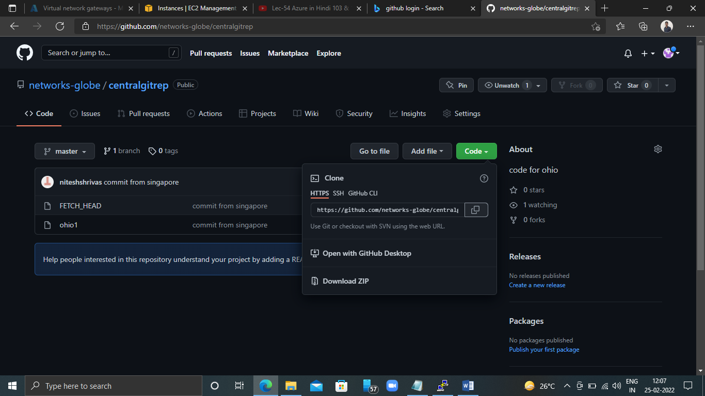

Now connect with central repo:-----

[root@ip-172-31-22-40 singit]# git remote add origin https://github.com/networks-globe/centralgitrep.git

[root@ip-172-31-22-40 singit]#

[root@ip-172-31-22-40 singit]# git log

fatal: your current branch 'master' does not have any commits yet

[root@ip-172-31-22-40 singit]# git status

On branch master

No commits yet

nothing to commit (create/copy files and use "git add" to track)

[root@ip-172-31-22-40 singit]#

**Now pull the data, which one has uploaded by ohiogit:----**

[root@ip-172-31-22-40 singit]# git pull origin master

warning: Pulling without specifying how to reconcile divergent branches is

discouraged. You can squelch this message by running one of the following

commands sometime before your next pull:

gitconfigpull.rebase false # merge (the default strategy)

gitconfigpull.rebase true # rebase

gitconfigpull.ff only # fast-forward only

You can replace "git config" with "git config --global" to set a default

preference for all repositories. You can also pass --rebase, --no-rebase,

or --ff-only on the command line to override the configured default per

invocation.

remote: Enumerating objects: 10, done.

remote: Counting objects: 100% (10/10), done.

remote: Compressing objects: 100% (4/4), done.

remote: Total 10 (delta 0), reused 10 (delta 0), pack-reused 0

Unpacking objects: 100% (10/10), 754 bytes | 377.00 KiB/s, done.

From https://github.com/networks-globe/centralgitrep

* branch master -> FETCH_HEAD

* [new branch] master -> origin/master

[root@ip-172-31-22-40 singit]#

[root@ip-172-31-22-40 singit]# git log

commit 8a41ada828f2c3769f717f6259fde578fdafdc84 (HEAD -> master, origin/master)

Author: nitesh<nitesh@gmail.com>

Date: Mon Jan 3 10:11:30 2022 +0000

commit from singapore

commit fdca6f2f51a3c23cd7c44662467eca6f89d9f012

Author: abhash<abhashkumar1993@gmail.com>

Date: Mon Jan 3 09:16:59 2022 +0000

mysecodn code from ohio

commit 840a9e7a67f0dfe182b9caa475b440a629e98909

Author: abhash<abhashkumar1993@gmail.com>

Date: Mon Jan 3 07:13:20 2022 +0000

my first commit from ohio

[root@ip-172-31-22-40 singit]#

**Now do some changes in ohio git file :---**

[root@ip-172-31-22-40 singit]# cat>> ohio1

changes from singapore site

[root@ip-172-31-22-40 singit]# cat ohio1

my name is khan

i am not terrorist

shahrukh khan

changes from singapore site

[root@ip-172-31-22-40 singit]# git status

On branch master

Changes not staged for commit:

(use "git add <file>..." to update what will be committed)

(use "git restore <file>..." to discard changes in working directory)

modified: ohio1

no changes added to commit (use "git add" and/or "git commit -a")

[root@ip-172-31-22-40 singit]#

Now add :----

[root@ip-172-31-22-40 singit]# git add .

[root@ip-172-31-22-40 singit]# git status

On branch master

Changes to be committed:

(use "git restore --staged <file>..." to unstage)

modified: ohio1

[root@ip-172-31-22-40 singit]#

Now commit the data :-----

[root@ip-172-31-22-40 singit]# git commit -m "my fisrt commit from singapore"

[master d769a3f] my fisrt commit from singapore

1 file changed, 1 insertion(+)

[root@ip-172-31-22-40 singit]# git status

On branch master

nothing to commit, working tree clean

[root@ip-172-31-22-40 singit]# git log

commit d769a3fb639f2e8f7da1943112d6a21c09b2b668 (HEAD -> master)

Author: abhi<abhashumrao1992@gmail.com>

Date: Fri Feb 25 06:50:10 2022 +0000

myfisrt commit from singapore

commit 8a41ada828f2c3769f717f6259fde578fdafdc84 (origin/master)

Author: nitesh<nitesh@gmail.com>

Date: Mon Jan 3 10:11:30 2022 +0000

commit from singapore

commit fdca6f2f51a3c23cd7c44662467eca6f89d9f012

Author: abhash<abhashkumar1993@gmail.com>

Date: Mon Jan 3 09:16:59 2022 +0000

mysecodn code from ohio

commit 840a9e7a67f0dfe182b9caa475b440a629e98909

Author: abhash<abhashkumar1993@gmail.com>

Date: Mon Jan 3 07:13:20 2022 +0000

my first commit from ohio

[root@ip-172-31-22-40 singit]#

Now see the status of changed data:--

[root@ip-172-31-22-40 singit]# git show d769a3fb639f2e8f7da1943112d6a21c09b2b668

commit d769a3fb639f2e8f7da1943112d6a21c09b2b668 (HEAD -> master)

Author: abhi<abhashumrao1992@gmail.com>

Date: Fri Feb 25 06:50:10 2022 +0000

myfisrt commit from singapore

diff --git a/ohio1 b/ohio1

index 53ddb0f..2be5125 100644

--- a/ohio1

+++ b/ohio1

@@ -1,3 +1,4 @@

my name is khan

i am not terrorist

shahrukh khan

+changes from singapore site

[root@ip-172-31-22-40 singit]#

**Now push the data from Singapore local repo to central repo:------**

[root@ip-172-31-22-40 singit]# git push origin master

Username for 'https://github.com': networks-globe

Password for 'https://networks-globe@github.com':

Enumerating objects: 5, done.

Counting objects: 100% (5/5), done.

Compressing objects: 100% (3/3), done.

Writing objects: 100% (3/3), 348 bytes | 348.00 KiB/s, done.

Total 3 (delta 0), reused 0 (delta 0), pack-reused 0

To https://github.com/networks-globe/centralgitrep.git

8a41ada..d769a3f master -> master

[root@ip-172-31-22-40 singit]#

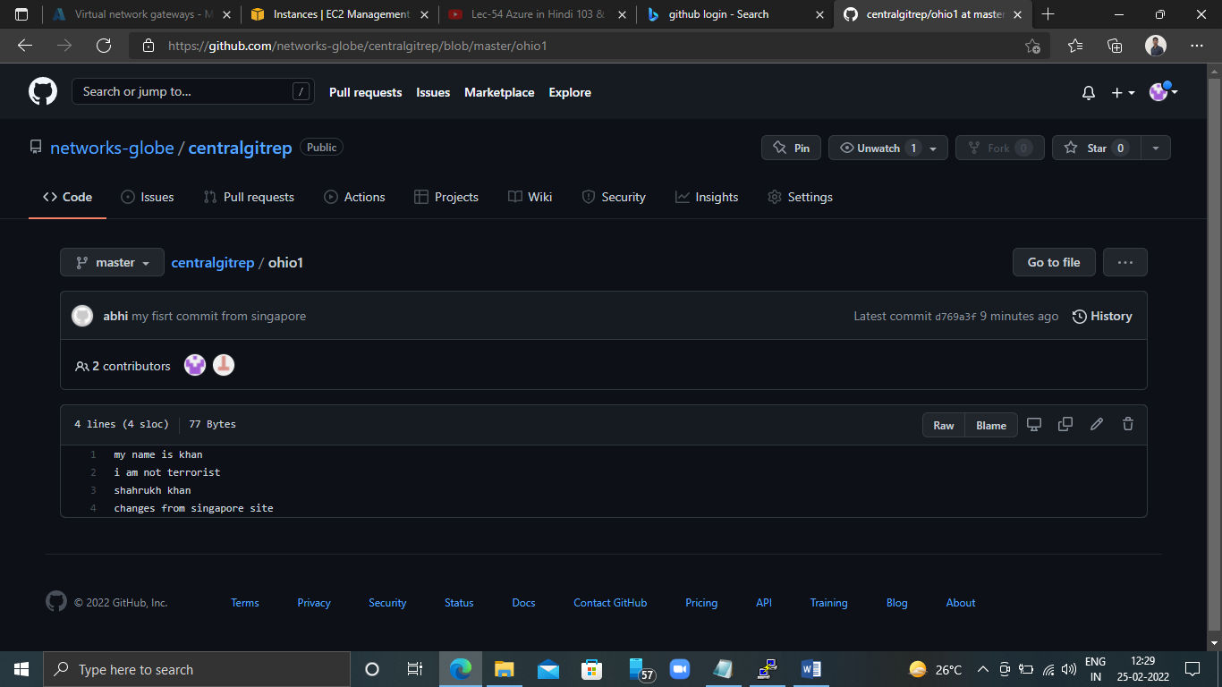

**Ohio**

**Now pull data from ohio region’s vm:---**

[root@ip-172-31-19-164 ohiogit]# git pull https://github.com/networks-globe/centralgitrep.git

warning: no common commits

remote: Enumerating objects: 13, done.

remote: Counting objects: 100% (13/13), done.

remote: Compressing objects: 100% (7/7), done.

remote: Total 13 (delta 0), reused 13 (delta 0), pack-reused 0

Unpacking objects: 100% (13/13), 1.04 KiB | 535.00 KiB/s, done.

From https://github.com/networks-globe/centralgitrep

* branch HEAD -> FETCH_HEAD

Successfully rebased and updated refs/heads/master.

[root@ip-172-31-19-164 ohiogit]# ls

FETCH_HEAD fileohio1 ohio1

[root@ip-172-31-19-164 ohiogit]#

[root@ip-172-31-19-164 ohiogit]# ls

FETCH_HEAD fileohio1 ohio1

[root@ip-172-31-19-164 ohiogit]# cat ohio1

my name is khan

i am not terrorist

shahrukh khan

changes from singapore site

[root@ip-172-31-19-164 ohiogit]#

**Now verify log file:------**

[root@ip-172-31-19-164 ohiogit]# git log

commit 40e9b99d65a2dc56391a808be99ca426d1d7c2b2 (HEAD -> master)

Author: abhash<abhashkumar1993@gmail.com>

Date: Thu Feb 24 12:58:30 2022 +0000

my second code from ohio

commit 72321201369c75a435efc17fd680519a2eda41e6

Author: abhash<abhashkumar1993@gmail.com>

Date: Thu Feb 24 12:20:44 2022 +0000

my first commit from ohio

commit d769a3fb639f2e8f7da1943112d6a21c09b2b668

Author: abhi<abhashumrao1992@gmail.com>

Date: Fri Feb 25 06:50:10 2022 +0000

myfisrt commit from singapore

commit 8a41ada828f2c3769f717f6259fde578fdafdc84

Author: nitesh<nitesh@gmail.com>

Date: Mon Jan 3 10:11:30 2022 +0000

commit from singapore

commit fdca6f2f51a3c23cd7c44662467eca6f89d9f012

Author: abhash<abhashkumar1993@gmail.com>

Date: Mon Jan 3 09:16:59 2022 +0000

mysecodn code from ohio

commit 840a9e7a67f0dfe182b9caa475b440a629e98909

Author: abhash<abhashkumar1993@gmail.com>

Date: Mon Jan 3 07:13:20 2022 +0000

my first commit from ohio

[1]+ Stopped git log

[root@ip-172-31-19-164 ohiogit]# git show d769a3fb639f2e8f7da1943112d6a21c09b2b668

commit d769a3fb639f2e8f7da1943112d6a21c09b2b668

Author: abhi<abhashumrao1992@gmail.com>

Date: Fri Feb 25 06:50:10 2022 +0000

myfisrt commit from singapore

diff --git a/ohio1 b/ohio1

index 53ddb0f..2be5125 100644

--- a/ohio1

+++ b/ohio1

@@ -1,3 +1,4 @@

my name is khan

i am not terrorist

shahrukh khan

+changes from singapore site

[root@ip-172-31-19-164 ohiogit]#

**Now see git ignore command:-----**

[root@ip-172-31-19-164 ohiogit]# vi .gitignore

*.css

*.java

~

~

It will ignore the .cssnd .java file

**Now add the .gitignore in local repo:---**

[root@ip-172-31-19-164 ohiogit]# git add .gitignore

[root@ip-172-31-19-164 ohiogit]# git commit -m "ingore file foramt"

[master 588fd05] ingore file foramt

1 file changed, 2 insertions(+)

create mode 100644 .gitignore

[root@ip-172-31-19-164 ohiogit]# git status

On branch master

Your branch and 'origin/master' have diverged,

and have 7 and 2 different commits each, respectively.

(use "git pull" to merge the remote branch into yours)

nothing to commit, working tree clean

[root@ip-172-31-19-164 ohiogit]#

**Now create some file which one we want to upload:----**

[root@ip-172-31-19-164 ohiogit]# touch file.txt file2.txt file3.java file4.css

[root@ip-172-31-19-164 ohiogit]# ls

FETCH_HEAD file2.txt file3.java file4.css fileohio1 file.txt ohio1

[root@ip-172-31-19-164 ohiogit]#

**See the status of local repo for commit of ready file:===**

[root@ip-172-31-19-164 ohiogit]# git status

On branch master

Your branch and 'origin/master' have diverged,

and have 7 and 2 different commits each, respectively.

(use "git pull" to merge the remote branch into yours)

Untracked files:

(use "git add <file>..." to include in what will be committed)

file.txt

file2.txt

only above two file showing here for commit, it is ignoring .css and .java file

nothing added to commit but untracked files present (use "git add" to track)

[root@ip-172-31-19-164 ohiogit]#

Now add file to local repo:--\

[root@ip-172-31-19-164 ohiogit]# git add .

[root@ip-172-31-19-164 ohiogit]# git status

On branch master

Your branch and 'origin/master' have diverged,

and have 7 and 2 different commits each, respectively.

(use "git pull" to merge the remote branch into yours)

Changes to be committed:

(use "git restore --staged <file>..." to unstage)

new file: file.txt

new file: file2.txt

[root@ip-172-31-19-164 ohiogit]#

Now commit

[root@ip-172-31-19-164 ohiogit]# git commit -m "ignore java and css"

[master dc2b051] ignore java and css

2 files changed, 0 insertions(+), 0 deletions(-)

create mode 100644 file.txt

create mode 100644 file2.txt

[root@ip-172-31-19-164 ohiogit]#

[root@ip-172-31-19-164 ohiogit]# git log

commit dc2b0513c9eef99b31f97f1ec40904db216aad3b (HEAD -> master)

Author: abhash<abhashkumar1993@gmail.com>

Date: Fri Feb 25 07:35:43 2022 +0000

ignore java and css

commit 588fd0535649772b5d204bc5338e2ca599e0780a

Author: abhash<abhashkumar1993@gmail.com>

Date: Fri Feb 25 07:27:39 2022 +0000

ingore file foramt

commit 40e9b99d65a2dc56391a808be99ca426d1d7c2b2

Author: abhash<abhashkumar1993@gmail.com>

Date: Thu Feb 24 12:58:30 2022 +0000

my second code from ohio

commit 72321201369c75a435efc17fd680519a2eda41e6

Author: abhash<abhashkumar1993@gmail.com>

Date: Thu Feb 24 12:20:44 2022 +0000

my first commit from ohio

[2]+ Stopped git log

[root@ip-172-31-19-164 ohiogit]# git show dc2b0513c9eef99b31f97f1ec40904db216aad3b

commit dc2b0513c9eef99b31f97f1ec40904db216aad3b (HEAD -> master)

Author: abhash<abhashkumar1993@gmail.com>

Date: Fri Feb 25 07:35:43 2022 +0000

ignore java and css

diff --git a/file.txt b/file.txt

new file mode 100644

index 0000000..e69de29

diff --git a/file2.txt b/file2.txt

new file mode 100644

index 0000000..e69de29

[root@ip-172-31-19-164 ohiogit]#

[root@ip-172-31-19-164 ohiogit]# git log -1

commit dc2b0513c9eef99b31f97f1ec40904db216aad3b (HEAD -> master)

Author: abhash<abhashkumar1993@gmail.com>

Date: Fri Feb 25 07:35:43 2022 +0000

ignore java and css

[root@ip-172-31-19-164 ohiogit]#

[root@ip-172-31-19-164 ohiogit]# git log -2

commit dc2b0513c9eef99b31f97f1ec40904db216aad3b (HEAD -> master)

Author: abhash<abhashkumar1993@gmail.com>

Date: Fri Feb 25 07:35:43 2022 +0000

ignore java and css

commit 588fd0535649772b5d204bc5338e2ca599e0780a

Author: abhash<abhashkumar1993@gmail.com>

Date: Fri Feb 25 07:27:39 2022 +0000

ingore file foramt

[root@ip-172-31-19-164 ohiogit]#

**Git branch: ------**

Now see the status of commit

[root@ip-172-31-22-40 singit]# git log --oneline

d769a3f (HEAD -> master, origin/master) my fisrt commit from singapore

8a41ada commit from singapore

fdca6f2 my secodn code from ohio

840a9e7 my first commit from ohio

[root@ip-172-31-22-40 singit]#

To check the current branch:0----

[root@ip-172-31-22-40 singit]# git branch

* master

[root@ip-172-31-22-40 singit]#

**Now create new branch:--**

[root@ip-172-31-22-40 singit]# git branch branch1

[root@ip-172-31-22-40 singit]# git branch

branch1

* master

[root@ip-172-31-22-40 singit]#

**When you create new branch then data of master branch will copy to newly created branch:-----check it**

[root@ip-172-31-22-40 singit]# git checkout branch1

Switched to branch 'branch1'

[root@ip-172-31-22-40 singit]#

[root@ip-172-31-22-40 singit]# git branch

* branch1 ---- current branch

master

[root@ip-172-31-22-40 singit]#

[root@ip-172-31-22-40 singit]# ls

FETCH_HEAD ohio1

[root@ip-172-31-22-40 singit]#

**Now see the commit status (which one committed from mater branch to newly created branch)**

[root@ip-172-31-22-40 singit]# git log --oneline

d769a3f (HEAD -> branch1, origin/master, master) my fisrt commit from singapore

8a41ada commit from singapore

fdca6f2 my secodn code from ohio

840a9e7 my first commit from ohio

[root@ip-172-31-22-40 singit]#

**Create new file and add to staging area and then commit it>------**

[root@ip-172-31-22-40 singit]# cat> branchfile1

branch file from mumbai

[root@ip-172-31-22-40 singit]# ls

branchfile1 FETCH_HEAD ohio1

[root@ip-172-31-22-40 singit]# git add .

[root@ip-172-31-22-40 singit]# git commit -m "my first commit from branch"

[branch1 fec52ff] my first commit from branch

1 file changed, 1 insertion(+)

create mode 100644 branchfile1

[root@ip-172-31-22-40 singit]#

**Now see the commit status:-------**

[root@ip-172-31-22-40 singit]# git log --oneline

fec52ff (HEAD -> branch1) my first commit from branch

d769a3f (origin/master, master) my fisrt commit from singapore

8a41ada commit from singapore

fdca6f2 my secodn code from ohio

840a9e7 my first commit from ohio

[root@ip-172-31-22-40 singit]#

**But it will not effect to master branch:--**

[root@ip-172-31-22-40 singit]# git checkout master

Switched to branch 'master'

[root@ip-172-31-22-40 singit]# git log --oneline

d769a3f (HEAD -> master, origin/master) my fisrt commit from singapore

8a41ada commit from singapore

fdca6f2 my secodn code from ohio

840a9e7 my first commit from ohio

[root@ip-172-31-22-40 singit]#

[root@ip-172-31-22-40 singit]# ls

FETCH_HEAD ohio1

[root@ip-172-31-22-40 singit]# git branch

branch1

* master

[root@ip-172-31-22-40 singit]#

[root@ip-172-31-22-40 singit]# git checkout branch1

Switched to branch 'branch1'

[root@ip-172-31-22-40 singit]# ls

branchfile1 FETCH_HEAD ohio1

[root@ip-172-31-22-40 singit]# git branch

* branch1

master

[root@ip-172-31-22-40 singit]# cat> branchfile2

second file of branch1

[root@ip-172-31-22-40 singit]# ls

branchfile1 branchfile2 FETCH_HEAD ohio1

[root@ip-172-31-22-40 singit]#

**If you will switch the branch before commit then data will show in master branch of branch1:------**

[root@ip-172-31-22-40 singit]# cat> branchfile2

second file of branch1

[root@ip-172-31-22-40 singit]# ls

branchfile1 branchfile2 FETCH_HEAD ohio1

[root@ip-172-31-22-40 singit]# git checkout master

Switched to branch 'master'

[root@ip-172-31-22-40 singit]# ls

branchfile2 FETCH_HEAD ohio1

[root@ip-172-31-22-40 singit]#

[root@ip-172-31-22-40 singit]# git checkout branch1

Switched to branch 'branch1'

[root@ip-172-31-22-40 singit]# ls

branchfile1 branchfile2 FETCH_HEAD ohio1

[root@ip-172-31-22-40 singit]# git add .

[root@ip-172-31-22-40 singit]# git commit -m "second commit from branch1"

[branch1 088d03f] second commit from branch1

1 file changed, 1 insertion(+)

create mode 100644 branchfile2

[root@ip-172-31-22-40 singit]# ls

branchfile1 branchfile2 FETCH_HEAD ohio1

[root@ip-172-31-22-40 singit]# git log --oneline

088d03f (HEAD -> branch1) second commit from branch1

fec52ff my first commit from branch

d769a3f (origin/master, master) my fisrt commit from singapore

8a41ada commit from singapore

fdca6f2 my secodn code from ohio

840a9e7 my first commit from ohio

[root@ip-172-31-22-40 singit]#

**Now you cannot see branch1 file after commit:----**

[root@ip-172-31-22-40 singit]# git checkout master

Switched to branch 'master'

[root@ip-172-31-22-40 singit]# ls

FETCH_HEAD ohio1

[root@ip-172-31-22-40 singit]#

**Git merge: ---**

**Merge data from master branch to branch1**

**Here we use pulling mechanism to merge branches**

**Newly added data will pull only**

**You can merge within local repo.**

**Switch to master branch then merge branch1 data:---**

[root@ip-172-31-22-40 singit]# git branch

branch1

* master

[root@ip-172-31-22-40 singit]#

[root@ip-172-31-22-40 singit]#

[root@ip-172-31-22-40 singit]#

[root@ip-172-31-22-40 singit]#

[root@ip-172-31-22-40 singit]#

[root@ip-172-31-22-40 singit]# ls

FETCH_HEAD ohio1

[root@ip-172-31-22-40 singit]# git log --oneline

d769a3f (HEAD -> master, origin/master) my fisrt commit from singapore

8a41ada commit from singapore

fdca6f2 my secodn code from ohio

840a9e7 my first commit from ohio

[root@ip-172-31-22-40 singit]# git merge branch1

Updating d769a3f..088d03f

Fast-forward

branchfile1 | 1 +

branchfile2 | 1 +

2 files changed, 2 insertions(+)

create mode 100644 branchfile1

create mode 100644 branchfile2

[root@ip-172-31-22-40 singit]#

**Now you can see merge data:----**

[root@ip-172-31-22-40 singit]# ls

branchfile1 branchfile2 FETCH_HEAD ohio1

[root@ip-172-31-22-40 singit]#

**Now you can see commit status:-----**

[root@ip-172-31-22-40 singit]# git log --oneline

088d03f (HEAD -> master, branch1) second commit from branch1

fec52ff my first commit from branch

d769a3f (origin/master) my fisrt commit from singapore

8a41ada commit from singapore

fdca6f2 my secodn code from ohio

840a9e7 my first commit from ohio

[root@ip-172-31-22-40 singit]#

**Now push data to central repo:---**

[root@ip-172-31-22-40 singit]# git push origin master

Username for 'https://github.com': networks-globe

Password for 'https://networks-globe@github.com':

Enumerating objects: 7, done.

Counting objects: 100% (7/7), done.

Compressing objects: 100% (4/4), done.

Writing objects: 100% (6/6), 576 bytes | 576.00 KiB/s, done.

Total 6 (delta 1), reused 0 (delta 0), pack-reused 0

remote: Resolving deltas: 100% (1/1), done.

To https://github.com/networks-globe/centralgitrep.git

d769a3f..088d03f master -> master

[root@ip-172-31-22-40 singit]#

**Git conflict :----( when different content will appear)**

When same file having different content in different brances if you do merge, conflict occurs (restore conflict then add and commit)

**Conflict occurs when merge braches: ------**

Create same file name in both branch with different content:==

[root@ip-172-31-22-40 singit]# clear

[root@ip-172-31-22-40 singit]#

[root@ip-172-31-22-40 singit]#

[root@ip-172-31-22-40 singit]# cat>umrao

abhash

[root@ip-172-31-22-40 singit]# git add .

[root@ip-172-31-22-40 singit]# git commit -m "first commit"

[master 4991ad1] first commit

1 file changed, 1 insertion(+)

create mode 100644 umrao

[root@ip-172-31-22-40 singit]# git branch

branch1

* master

[root@ip-172-31-22-40 singit]# git checkout branch1

Switched to branch 'branch1'

[root@ip-172-31-22-40 singit]# git branch

* branch1

master

[root@ip-172-31-22-40 singit]# cat>umrao

anand

[root@ip-172-31-22-40 singit]# git add .

[root@ip-172-31-22-40 singit]# git commit -m "commit form branch1"

[branch1 fb50ad6] commit form branch1

1 file changed, 1 insertion(+)

create mode 100644 umrao

[root@ip-172-31-22-40 singit]#

[root@ip-172-31-22-40 singit]# git branch

* branch1

master

[root@ip-172-31-22-40 singit]# git checkout master

Switched to branch 'master'

[root@ip-172-31-22-40 singit]# git merge branch1

CONFLICT (add/add): Merge conflict in umrao

Auto-merging umrao

Automatic merge failed; fix conflicts and then commit the result.

[root@ip-172-31-22-40 singit]#

[root@ip-172-31-22-40 singit]# viumrao

abhash

=======

anand

he is from noida

~

~

[root@ip-172-31-22-40 singit]# git status

On branch master

You have unmerged paths.

(fix conflicts and run "git commit")

(use "git merge --abort" to abort the merge)

Unmerged paths:

(use "git add <file>..." to mark resolution)

both added: umrao

no changes added to commit (use "git add" and/or "git commit -a")

[root@ip-172-31-22-40 singit]# git add .

[root@ip-172-31-22-40 singit]# git commit -m "conflict resolution"

[master c0b6eb0] conflict resolution

[root@ip-172-31-22-40 singit]# git log --oneline

c0b6eb0 (HEAD -> master) conflict resolution

fb50ad6 (branch1) commit form branch1

4991ad1 first commit

088d03f (origin/master) second commit from branch1

fec52ff my first commit from branch

d769a3f my fisrt commit from singapore

8a41ada commit from singapore

fdca6f2 my secodn code from ohio

840a9e7 my first commit from ohio

[root@ip-172-31-22-40 singit]#

**Git stashing>**

Suppose you are implementing a new feature for your product. Your code is in progress and suddenly a customer escalation comes because of this, you have to keep aside your new feature work for few hours.

You can not commit your partial code and also connot throw away your changes so you need some temporary storage , where you can store your partial changes and later on commit it

# to stash an item (only to modified files not new files)

[root@ip-172-31-22-40 ec2-user]# ls

singit

[root@ip-172-31-22-40 ec2-user]# cdsigin

bash: cd: sigin: No such file or directory

[root@ip-172-31-22-40 ec2-user]# cdsingit/

[root@ip-172-31-22-40 singit]#

[root@ip-172-31-22-40 singit]#

[root@ip-172-31-22-40 singit]# touch demofl

[root@ip-172-31-22-40 singit]# git add .

[root@ip-172-31-22-40 singit]# git commit -m "demosatsh"

[master 88eab0e] demosatsh

2 files changed, 0 insertions(+), 0 deletions(-)

create mode 100644 .umrao.swp

create mode 100644 demofl

[root@ip-172-31-22-40 singit]# git branch

branch1

* master

[root@ip-172-31-22-40 singit]#

[root@ip-172-31-22-40 singit]# vi demofl

My first code

[root@ip-172-31-22-40 singit]# cat demofl

My first code

[root@ip-172-31-22-40 singit]# git stash

Saved working directory and index state WIP on master: 88eab0e demosatsh

[root@ip-172-31-22-40 singit]#

[root@ip-172-31-22-40 singit]# videmofl

[root@ip-172-31-22-40 singit]# catdemofl

[root@ip-172-31-22-40 singit]#

[root@ip-172-31-22-40 singit]# git stash list

stash@{0}: WIP on master: 88eab0e demosatsh

[root@ip-172-31-22-40 singit]# git stash list

stash@{0}: WIP on master: 88eab0e demosatsh

[root@ip-172-31-22-40 singit]# videmofl

[root@ip-172-31-22-40 singit]# catdemofl

my second for client

[root@ip-172-31-22-40 singit]# git stash

Saved working directory and index state WIP on master: 88eab0e demosatsh

[root@ip-172-31-22-40 singit]# git stash list

stash@{0}: WIP on master: 88eab0e demosatsh

stash@{1}: WIP on master: 88eab0e demosatsh

[root@ip-172-31-22-40 singit]# catdemofl

[root@ip-172-31-22-40 singit]#

**Now we will do work on old file code:-----**

[root@ip-172-31-22-40 singit]# catdemofl

[root@ip-172-31-22-40 singit]# git stash apply stash@{1}

On branch master

Changes not staged for commit:

(use "git add <file>..." to update what will be committed)

(use "git restore <file>..." to discard changes in working directory)

modified: demofl

no changes added to commit (use "git add" and/or "git commit -a")

[root@ip-172-31-22-40 singit]# catdemofl

My first code

**Now add and commit first code: ---**

[root@ip-172-31-22-40 singit]# git add .

\[root@ip-172-31-22-40 singit]# git commit -m "my first code"

[master c2ee0e5] my first code

1 file changed, 1 insertion(+)

[root@ip-172-31-22-40 singit]# git log --oneline

c2ee0e5 (HEAD -> master) my first code

88eab0e demosatsh

c0b6eb0 conflict resolution

fb50ad6 (branch1) commit form branch1

4991ad1 first commit

088d03f (origin/master) second commit from branch1

fec52ff my first commit from branch

d769a3f my fisrt commit from singapore

8a41ada commit from singapore

fdca6f2 my secodn code from ohio

840a9e7 my first commit from ohio

[root@ip-172-31-22-40 singit]#

**Git reset -----**

Git reset is a powerfull command that is used to undo local changes to the state of a git repo.

To reset the change from both staging area and working directory at a time

[root@ip-172-31-22-40 singit]# ls

branchfile1 branchfile2demofl FETCH_HEAD ohio1 umrao

[root@ip-172-31-22-40 singit]# git branch

branch1

* master

[root@ip-172-31-22-40 singit]# cat ?

cat: '?': No such file or directory

[root@ip-172-31-22-40 singit]# cat>testingfile

helloanand

[root@ip-172-31-22-40 singit]# git add .

[root@ip-172-31-22-40 singit]# git status

On branch master

Changes to be committed:

(use "git restore --staged <file>..." to unstage)

new file: testingfile

[root@ip-172-31-22-40 singit]#

**Now reset the code from staging area:----**

[root@ip-172-31-22-40 singit]# git reset .

[root@ip-172-31-22-40 singit]# git status

On branch master

Untracked files:

(use "git add <file>..." to include in what will be committed)

testingfile

nothing added to commit but untracked files present (use "git add" to track)

[root@ip-172-31-22-40 singit]#

[root@ip-172-31-22-40 singit]# git add .

[root@ip-172-31-22-40 singit]# git status

On branch master

Changes to be committed:

(use "git restore --staged <file>..." to unstage)

new file: testingfile

**now reset code from both working and staging area:----**

[root@ip-172-31-22-40 singit]# git reset --hard

HEAD is now at c2ee0e5 my first code

[root@ip-172-31-22-40 singit]# git status

On branch master

nothing to commit, working tree clean

[root@ip-172-31-22-40 singit]#

**GIT Revert :----**

The revert command helps you undo an existing commit.

It does not delete any data in this process instead rather Git creates a new commit with the included files reverted to their previous state so, your version control history moves forward while the state of your file moves backward.

# **Git Revert**

[**git checkout**](https://www.atlassian.com/git/tutorials/undoing-changes/git-revert) [**git clean**](https://www.atlassian.com/git/tutorials/undoing-changes/git-revert) [**git revert**](https://www.atlassian.com/git/tutorials/undoing-changes/git-revert) [**git reset**](https://www.atlassian.com/git/tutorials/undoing-changes/git-revert) [**git rm**](https://www.atlassian.com/git/tutorials/undoing-changes/git-revert)

The git revert command can be considered an 'undo' type command, however, it is not a traditional undo operation. Instead of removing the commit from the project history, it figures out how to invert the changes introduced by the commit and appends a new commit with the resulting inverse content. This prevents Git from losing history, which is important for the integrity of your revision history and for reliable collaboration.

Reverting should be used when you want to apply the inverse of a commit from your project history. This can be useful, for example, if you’re tracking down a bug and find that it was introduced by a single commit. Instead of manually going in, fixing it, and committing a new snapshot, you can use git revert to automatically do all of this for you.

## **How it works**

The git revert command is used for undoing changes to a repository's commit history. Other 'undo' commands like, [git checkout](https://www.atlassian.com/git/tutorials/using-branches/git-checkout) and [git reset](https://www.atlassian.com/git/tutorials/undoing-changes/git-reset), move the HEAD and branch ref pointers to a specified commit. Git revert also takes a specified commit, however, git revert does not move ref pointers to this commit. A revert operation will take the specified commit, inverse the changes from that commit, and create a new "revert commit". The ref pointers are then updated to point at the new revert commit making it the tip of the branch.

Reset === before commit=====applicable on private file(local repo)

Revert -=== after commit===== applicable on public file(central repo)

Tags: ----tag operation allows giving meaningful name to a specific version in the repository.

**Git hub clone:----**

# OpenGitHub website

#login and choose existing repository.

#now, go to your Linux machine, and run command

#git clone <url of GitHub repo>

#It creates a local repo automatically in the Linux machine with the same name as in GitHub account.

login as: ec2-user

Authenticating with public key "imported-openssh-key"

Last login: Fri Feb 25 09:17:35 2022 from 103.177.174.158

[ec2-user@ip-172-31-22-40 ~]$

[ec2-user@ip-172-31-22-40 ~]$ sudosu

[root@ip-172-31-22-40 ec2-user]#

[root@ip-172-31-22-40 ec2-user]#

[root@ip-172-31-22-40 ec2-user]# ls

singit

[root@ip-172-31-22-40 ec2-user]# cdsingit/

[root@ip-172-31-22-40 singit]# ls

branchfile1 branchfile2demofl FETCH_HEAD ohio1 umrao

[root@ip-172-31-22-40 singit]# git status

On branch master

Changes not staged for commit:

(use "git add/rm<file>..." to update what will be committed)

(use "git restore <file>..." to discard changes in working directory)

deleted: .umrao.swp

no changes added to commit (use "git add" and/or "git commit -a")

[root@ip-172-31-22-40 singit]# git log

commit c2ee0e513e68f4a5b5b0a25931891b764a3402cc (HEAD -> master)

Author: abhi<abhashumrao1992@gmail.com>

Date: Fri Feb 25 09:25:52 2022 +0000

my first code

commit 88eab0e0031c2df0660353b763e79b6c1f1c7468

Author: abhi<abhashumrao1992@gmail.com>

Date: Fri Feb 25 09:18:50 2022 +0000

demosatsh

commit c0b6eb08e1d408987c3ce17407983332e144ccb9

Merge: 4991ad1 fb50ad6

Author: abhi<abhashumrao1992@gmail.com>

Date: Fri Feb 25 08:56:16 2022 +0000

conflict resolution

commit fb50ad6f95dee9786a50e74d69dda01f3d47b412 (branch1)

Author: abhi<abhashumrao1992@gmail.com>

Date: Fri Feb 25 08:49:19 2022 +0000

:

[1]+ Stopped git log

^C^C

**Create a file to test revert operation:---**

[root@ip-172-31-22-40 singit]# cat>revertfile

akash

[root@ip-172-31-22-40 singit]#

**Then add file to staging area :---**

[root@ip-172-31-22-40 singit]# git add .

[root@ip-172-31-22-40 singit]# git commit -m "this is my first commit for revert"

[master ce6577e] this is my first commit for revert

2 files changed, 1 insertion(+)

delete mode 100644 .umrao.swp

create mode 100644 revertfile

**do wrong changes in revert file:---**

[root@ip-172-31-22-40 singit]# catrevertfile

akash

[root@ip-172-31-22-40 singit]# cat>>revertfile

ajay

[root@ip-172-31-22-40 singit]# git add .

[root@ip-172-31-22-40 singit]# git commit -m "right commit"

[master 6a8b3e0] wrong commit

1 file changed, 1 insertion(+)

[root@ip-172-31-22-40 singit]# git log

commit 6a8b3e080a10c13c7199d7e55887ffad8dd16217 (HEAD -> master)

Author: abhi<abhashumrao1992@gmail.com>

Date: Fri Feb 25 12:24:19 2022 +0000

wrong commit

commit 47a223d555413d090f60eff3ff543b5b6b2f53c5

Author: abhi<abhashumrao1992@gmail.com>

Date: Fri Feb 25 12:19:09 2022 +0000

this is my wrong entry in revertfile

commit ce6577ecc22d64d3ccc7b0148a622ab77ba3baa5

Author: abhi<abhashumrao1992@gmail.com>

Date: Fri Feb 25 12:18:10 2022 +0000

this is my first commit for revert

commit c2ee0e513e68f4a5b5b0a25931891b764a3402cc

Author: abhi<abhashumrao1992@gmail.com>

Date: Fri Feb 25 09:25:52 2022 +0000

my first code

:

[root@ip-172-31-22-40 singit]# catrevertfile

akash

ajay ---- wrong entry

[root@ip-172-31-22-40 singit]#

[root@ip-172-31-22-40 singit]# git revert 6a8b3e080a10c13c7199d7e55887ffad8dd16217

[master a9f16dd] Revert "wrong commit" please ingore this commit

1 file changed, 1 deletion(-)

[root@ip-172-31-22-40 singit]#

[root@ip-172-31-22-40 singit]# catrevertfile

Akash

--------- wrong entry removed from here

[root@ip-172-31-22-40 singit]#

[root@ip-172-31-22-40 singit]# git log

commit a9f16dd34042db9bce6387fcbf57f1a57f9fcfa0 (HEAD -> master)

Author: abhi<abhashumrao1992@gmail.com>

Date: Fri Feb 25 12:29:16 2022 +0000

Revert "wrong commit" please ignoreprevious this commit

This reverts commit 6a8b3e080a10c13c7199d7e55887ffad8dd16217.

commit 6a8b3e080a10c13c7199d7e55887ffad8dd16217

Author: abhi<abhashumrao1992@gmail.com>

Date: Fri Feb 25 12:24:19 2022 +0000

wrong commit

commit 47a223d555413d090f60eff3ff543b5b6b2f53c5

Author: abhi<abhashumrao1992@gmail.com>

Date: Fri Feb 25 12:19:09 2022 +0000

this is my wrong entry in revertfile

commit ce6577ecc22d64d3ccc7b0148a622ab77ba3baa5

Author: abhi<abhashumrao1992@gmail.com>

Date: Fri Feb 25 12:18:10 2022 +0000:

**Remove untracked file:-----**

[root@ip-172-31-22-40 singit]#

[root@ip-172-31-22-40 singit]# touch file1 file2 file3

[root@ip-172-31-22-40 singit]# git status

On branch master

Untracked files:

(use "git add <file>..." to include in what will be committed)

file1

file2

file3

these above 3 files are untracked

nothing added to commit but untracked files present (use "git add" to track)

[root@ip-172-31-22-40 singit]#

**To check which one file you want to delete:------**

[root@ip-172-31-22-40 singit]# git clean -n

Would remove file1

Would remove file2

Would remove file3

[root@ip-172-31-22-40 singit]#

**Now remove these files:----**

[root@ip-172-31-22-40 singit]# git clean -f

Removing file1

Removing file2

Removing file3

[root@ip-172-31-22-40 singit]#

**Git tag:-----**

[root@ip-172-31-22-40 singit]# git log --oneline

a9f16dd (HEAD -> master) Revert "wrong commit" please ingore this commit

6a8b3e0 wrong commit

47a223d this is my wrong entry in revertfile

ce6577e this is my first commit for revert

c2ee0e5 my first code

88eab0e demosatsh ----tag to this one

c0b6eb0 conflict resolution

fb50ad6 (branch1) commit form branch1

4991ad1 first commit

088d03f (origin/master) second commit from branch1

fec52ff my first commit from branch

d769a3f my fisrt commit from singapore

8a41ada commit from singapore

fdca6f2 my secodn code from ohio

840a9e7 my first commit from ohio

[root@ip-172-31-22-40 singit]# git tag -a important -m "this is very imp commit" 88eab0e

[root@ip-172-31-22-40 singit]# git tag

important

[root@ip-172-31-22-40 singit]#

**To see status with tag name:------**

[root@ip-172-31-22-40 singit]# git show important

tag important

Tagger: abhi<abhashumrao1992@gmail.com>

Date: Fri Feb 25 12:36:37 2022 +0000

this is very imp commit

commit 88eab0e0031c2df0660353b763e79b6c1f1c7468 (tag: important)

Author: abhi<abhashumrao1992@gmail.com>

Date: Fri Feb 25 09:18:50 2022 +0000

demosatsh

diff --git a/.umrao.swp b/.umrao.swp

new file mode 100644

index 0000000..17580e8

Binary files /dev/null and b/.umrao.swp differ

diff --git a/demofl b/demofl

new file mode 100644

index 0000000..e69de29

[root@ip-172-31-22-40 singit]#

**Now delete the tag:-----**

[root@ip-172-31-22-40 singit]# git tag -d important

Deleted tag 'important' (was b8f5c6e)

[root@ip-172-31-22-40 singit]# git log --oneline

a9f16dd (HEAD -> master) Revert "wrong commit" please ingore this commit

6a8b3e0 wrong commit

47a223d this is my wrong entry in revertfile

ce6577e this is my first commit for revert

c2ee0e5 my first code

88eab0e demosatsh

c0b6eb0 conflict resolution

fb50ad6 (branch1) commit form branch1

4991ad1 first commit

088d03f (origin/master) second commit from branch1

fec52ff my first commit from branch

d769a3f my fisrt commit from singapore

8a41ada commit from singapore

fdca6f2 my secodn code from ohio

840a9e7 my first commit from ohio

[root@ip-172-31-22-40 singit]#

**Github clone: ----**

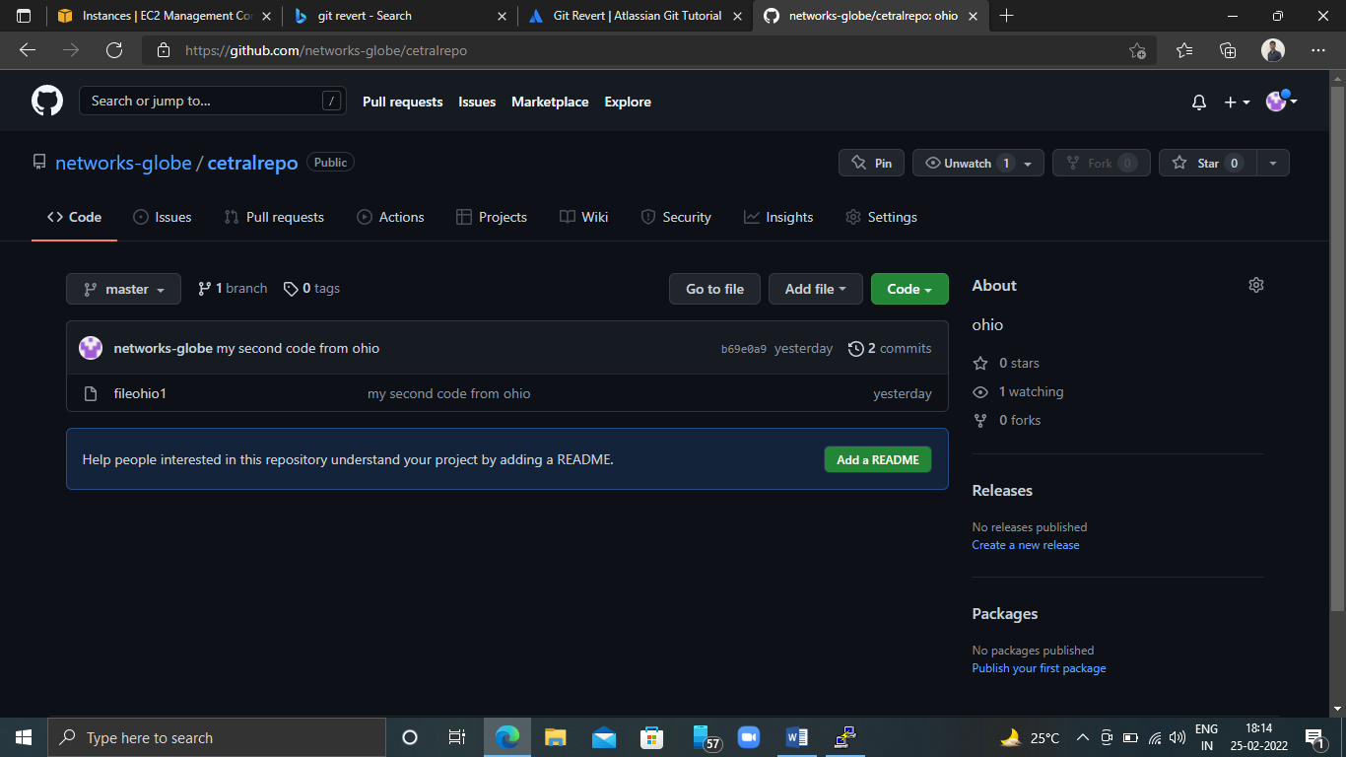

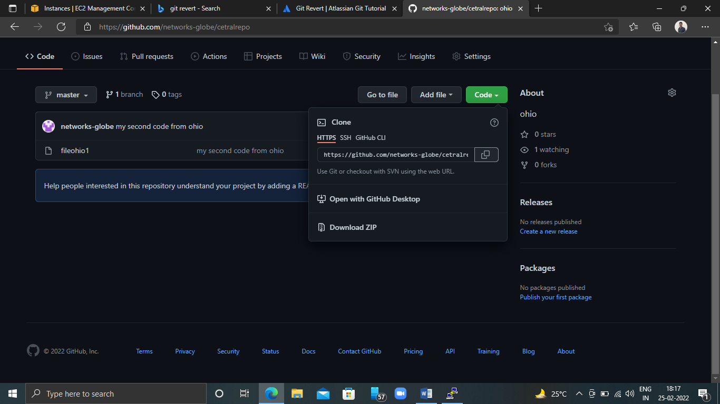

[root@ip-172-31-22-40 singit]# git clone https://github.com/networks-globe/cetralrepo.git

Cloning into 'cetralrepo'...

remote: Enumerating objects: 6, done.

remote: Counting objects: 100% (6/6), done.

remote: Compressing objects: 100% (2/2), done.

remote: Total 6 (delta 0), reused 6 (delta 0), pack-reused 0

Unpacking objects: 100% (6/6), 467 bytes | 116.00 KiB/s, done.

[root@ip-172-31-22-40 singit]#

[root@ip-172-31-22-40 singit]# ls

branchfile1 cetralrepo FETCH_HEAD revertfile

branchfile2 demofl ohio1 umrao

[root@ip-172-31-22-40 singit]# cdcetralrepo/

[root@ip-172-31-22-40 cetralrepo]# ls

fileohio1

[root@ip-172-31-22-40 cetralrepo]#

**Now create new file in clone repo and add then commit and push to central repo(github):--**

[root@ip-172-31-22-40 cetralrepo]# ls

fileohio1

[root@ip-172-31-22-40 cetralrepo]# touchfilehippo

[root@ip-172-31-22-40 cetralrepo]# git add .

[root@ip-172-31-22-40 cetralrepo]# git commit -m "newone commit"

[master bc88d31] newone commit

1 file changed, 0 insertions(+), 0 deletions(-)

create mode 100644 filehippo

[root@ip-172-31-22-40 cetralrepo]# git push origin master

Username for 'https://github.com': networks-globe

Password for 'https://networks-globe@github.com':

Enumerating objects: 4, done.

Counting objects: 100% (4/4), done.

Compressing objects: 100% (2/2), done.

Writing objects: 100% (3/3), 271 bytes | 271.00 KiB/s, done.

Total 3 (delta 0), reused 0 (delta 0), pack-reused 0

To https://github.com/networks-globe/cetralrepo.git

b69e0a9..bc88d31 master -> master

[root@ip-172-31-22-40 cetralrepo]#

